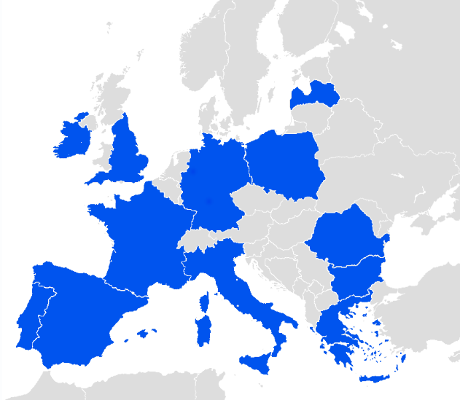

8 October 2019, European Parliament, Brussels

Tackling tobacco-related chronic diseases in Europe: Novel data from the Horizon 2020 TackSHS project reveals the results of exposure to secondhand smoke (SHS) from cigarettes and second-hand aerosols (SHA) from electronic cigarettes on the respiratory health of European population, the burden of associated mortality and morbidity, and economic consequences for national and European welfare.
These important findings were presented for discussion to a wide audience of about 100 European stakeholders during the Project Final Conference at the European Parliament on 8 October, kindly hosted by MEP Cristian-Silviu Buşoi and MEP Rosa Esteràs Ferragut.
Despite the tremendous effort to adopt and implement smoking bans around the European Union (EU) in the last decade, daily exposure to SHS among non-smokers is still highly prevalent across European countries. On average it affects 31% of population, ranging between 24% in Ireland and 68% in Greece, especially in indoor and outdoor settings of hospitality venues, workplaces, and private homes and cars.
What should we still do to protect the health of each and every European citizen, the health of future generation from this harmful exposure?
In pursuit of healthy populations protected from tobacco and second-hand smoke, as the title of the Conference stated, researchers from Ireland, Italy, Scotland, Spain and Greece had an honor of sharing key messages and recommendations deriving from 4 years of scientific studies under the TackSHS project. International audience of public health advocates, the EU and national officials and country representatives, academics, health care professionals, representatives of medical societies, public health associations and health-oriented NGOs, journalists and media – all the attendees joint forces in the discussion to further advance tobacco control and take necessary measures to protect public health.
After a welcoming word of MEP Bușoi, the Conference was launched with the presentations of Mrs. Thea Emmerling (Head of Unit, the Cross-border health care and tobacco control, DG SANTE, European Commission) and Dr. Francisco Lozano (President, European Network for Smoking and Tobacco Prevention) on the state of tobacco control in Europe and related policy priorities. The opening session was followed by a comprehensive project overview delivered by its coordinator, Prof. Esteve Fernández (Director, Tobacco Control Unit at the Catalan Institute of Oncology).
Further on, during an interactive debate moderated by Dr. Armando Peruga (Former Programme Manager of WHO's Tobacco Free Initiative), participating researchers from 6 European countries shared worrying numbers concerning: 1) secondhand tobacco smoke exposure, electronic cigarette use and exposure to their aerosols; and 2) burden of SHS exposure.
Daily exposure to SHS among non-smokers is highly prevalent in most European countries (31% overall, ranging between 24% in Ireland and 68% in Greece), especially in indoor and outdoor settings of hospitality venues, workplaces, and homes and cars.
Smoking occurs and SHS is present in almost all outdoor terraces of bars and restaurants across Europe, even in countries with legislation in these settings. Moreover, smoking occurs and SHS is present in most playgrounds and entrances to schools across Europe, especially in deprived neighborhoods and countries with lower tobacco control climate.
TobaccoFree Research Institute Ireland (TFRI) was the National Representative for Ireland in WP 2 and did the studies of exposure to nicotine in Dublin schools, playgrounds, and outside areas in pubs.
TFRI was also the Irish partner for the WP3, 12 country survey of prevalence of smoking, ecigs usage, secondhand smoke exposure (SHS) and aerosol exposure from ecigs (SHA)
TFRI was the Principal Investigator (PI) for the only clinical study in TackSHS where personal exposure to SHS was measured, as PM2.5, and every breath recorded in 30 Asthmatic and 30 COPD patients during a planned visit to a legal outside area of a pub. Patients were studied in Czechia, Spain and Ireland. Very high levels of exposure were recorded and the accompanying changes in breathing noted. As a result, the TackSHS consortium concluded that these areas are not safe for patients and recommended that EU countries take action.
Sheila Keogan, Hannah Byrne and Luke Clancy were the TFRI researchers.

Across Europe, three out of five smokers allow smoking in their homes, with very high levels of SHS exposure detected, potentially affecting children and other bystanders. In addition, SHS levels in cars of smokers are very high, with nicotine concentrations exceeding those observed in smokers’ homes.

The studies led to a conclusion that the burden attributable to SHS exposure is still substantial in the EU, mainly due to SHS exposure at home. Only in 2017, among children aged 0-14 years, exposure to SHS at home was associated with 344 deaths (1.5% of total deaths in children) and 37,000 disability-adjusted life years (0.75% of total DALYs), whereas in non-smoking adults it was responsible of 30,000 deaths (0.6% of total deaths) and 712,000 DALYs (0.5% of total DALYs).
Furthermore, the annual cost of lost DALYs due to exposure to SHS is 356 million (of Purchasing Power Parity Adjusted euro of year 2017) on average in the EU 28 Member States. Differences around this average value are substantial. Germany is the Member State with the highest losses (1694.69 million euro) and Malta (10.55 million euro) with the lowest ones. Such differences reflect mostly differences in population size but also differences in the prevalence of exposure to SHS.
Economic simulation modeling predicted that, over 2020-2024, a scenario of complete “smoke-free homes” would generate health care cost reductions ranging from 40 million euro in Bulgaria to over 200 Million euros in Germany. In a scenario of no SHS exposure at all, health care cost savings would be substantially higher, reaching for example 800 million euro only for Germany.
With regards to electronic cigarette use and exposure to their aerosols, the analysis demonstrated that the prevalence of use is low and diverse in Europe, more frequent among youth and usually concurrent with traditional cigarette smoking. The tests confirmed that electronic cigarette use impairs air quality with particulate matter, nicotine, volatile organic compounds, among others; while individuals exposed to electronic cigarettes aerosol showed immediate alterations of their lung function (respiratory mechanics and exhaled biomarkers) and experienced symptoms of eye, nose and throat irritation.
During the Conference, Prof. Esteve Fernández and Prof. Constantine Vardavas (GACD Lung Diseases Programme Co-Chair) addressed the above-mentioned numbers from the policy prospective. So much loss in precious human lives, including children, preventable health conditions and economic burden could be evaded and, hopefully, will be by committed and coordinated actions of national and European policy-makers. Project Consortium suggests the following measures for urgent consideration of the governments:

- Comprehensive policies and interventions to tackle tobacco consumption continue to be necessary with targeting of specific populations groups with higher prevalence rates.
- Increased monitoring and enforcement of smoke-free legislation is necessary, especially in workplaces and hospitality venues.
- Smoke-free legislation should be extended to outdoor areas (terraces, playgrounds, entrances) to discourage smokers, protect bystanders (including specific groups such as children and patients with lung chronic conditions), and to increase public awareness.
- Smoke-free homes should be promoted through evidence-based interventions at multiple levels.
- European governments should set national targets to reduce the proportion of children exposed to SHS.
- European governments should introduce smoke-free policies to regulate smoking inside private cars.
- To protect bystanders from secondhand aerosols from electronic cigarettes, policies to restrict their use in enclosed public spaces should be introduced.
- More research on the mid- and long-term effects of acute and chronic exposure to aerosols of electronic cigarettes by bystanders is needed, targeting specific population groups (children, patients with lung chronic diseases).
Closing speeches of Prof. Sally Haw (Professor of Public & Population Health in Health Sciences Stirling, University of Stirling) and Dr. Karim Berkouk (Deputy Head of Unit, Unit “Combating diseases”, DG for Research and Innovation, European Commission) focused on the role and the future of research in this field, and importance of research to combat tobacco-related NCDs respectively, placing TackSHS in the broader picture where it unites science and policy.
In the end, the outcomes of TackSHS project aim to serve as a solid base for addressing health inequalities caused by the use of conventional tobacco and electronic cigarettes. TackSHS results provide scientific evidence much-needed to facilitate urgent policy changes such as closing legislation gaps in regulation of novel and emerging products, while improving and strengthening comprehensive smoking bans in every EU Member State.

Notes to editors

Event material

Full agenda - https://bit.ly/33bhL4o
Leaflet with Key Messages and Recommendations - https://bit.ly/339nDLB

About the project
The TackSHS project aims to comprehensively elucidate the impact that exposure to secondhand smoke (SHS) from cigarettes and second-hand aerosols (SHA) from electronic cigarettes have on the respiratory health of the European population according to socioeconomic characteristics and other determinants.
The TackSHS project involves a series of coordinated studies carried out by 11 academic and public health organisations from six European countries. The project investigates: a) the determinants of SHS and SHA exposure assessed at the individual level (surveys on representative general population samples) and in common environments (environmental sampling in specific settings); b) the overall disease burden, mortality and morbidity attributable to such exposure; and c) its economic impact in terms of direct health care costs. The project also examines specific acute respiratory health changes in healthy individuals and patients with respiratory diseases exposed to SHS and SHA. In addition, the project examines the effectiveness of a novel intervention to reduce SHS exposure in households where smoking is permitted. All these studies are inter-related and involve collaborative coordination among the participant organisations.
The comprehensive, integrated approach of the TackSHS project enabled an important step forward from the current status quo in the understanding of the impact of SHS and SHA exposure on health and provide the basis for health policy recommendations to help European countries to further reduce the harm caused by SHS and SHA exposure.

Project partners

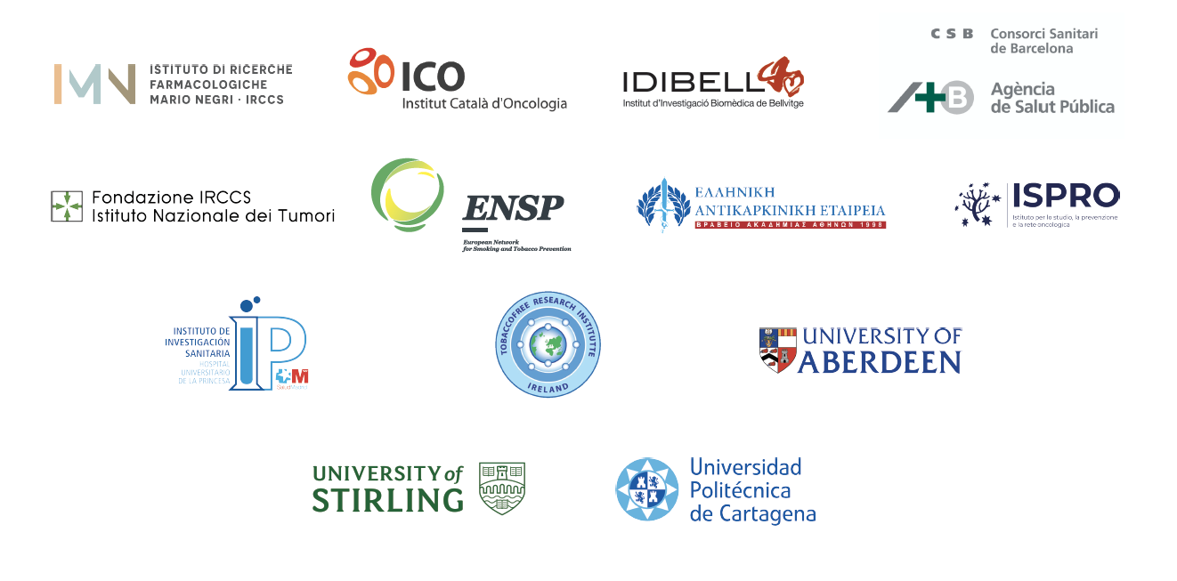

Learn more

web: http://tackshs.eu twitter: @TackshsProject mail: info@tackshs.eu

